**SMART FLOOR VACUUM CLEANER**

**Project Report**

**PCS 292-Engineering Design Project**

**End-Semester Evaluation**

**Submitted by:**

**(801732025) JHONSY BANSAL**

**(801832016) GURKIRAT SINGH**

**(801832018) HARMANDEEP SINGH**

**(801832023) KAMAL KANT**

**ME First Year, CS**

**Group No: _2_**

Submitted to

Dr. Ashima Singh

Asstt. Professor, CSED



**Computer Science and Engineering Department  
TIET, Patiala  
  
May 2019**

**ABSTRACT**

With the advancement of technology, robots are getting more attention of researchers to make life of mankind comfortable. Households of today are becoming smarter and more automated. Home automation delivers convenience and creates more time for people. Domestic robots are entering the homes and people’s daily lives, but it is yet a relatively new and immature market. However, a growth is predicted and the adoption of domestic robots is evolving. This project presents the design, development and fabrication of prototype Smart Floor Vacuum Robot. This Robot operates in autonomous mode as well as can be switched ON and OFF from the Android App, unleashing the power of IoT. 3D printed Model, Arduino UNO, IR Sensor, Fan Blower, Dual Motor Driver, MOS FET Driver Module, Micro Metal Gear motor and 12V Battery are main component used to achieve the goal of this project. Vacuum Robot will have several criteria that are user-friendly. This work can be very useful in improving life style of mankind.

**DECLARATION**

We hereby declare that the design principles and working prototype model of the project entitled Smart Vacuum Cleaner is an authentic record of our own work carried out in the Computer Science and Engineering Department, TIET, Patiala, under the guidance of Dr. Ashima Singh during second semester (2019).

Date: 10/05/2019

|  |  |  |
| --- | --- | --- |
| **Roll No.** | **Name** | **Signature** |
| 801732025 | JHONSY BANSAL |  |
| 801832016 | GURKIRAT SINGH |  |
| 801832018 | HARMANDEEP SINGH |  |
| 801832023 | KAMAL KANT |  |

*Counter Signed By:*

Faculty Mentor:

Dr. Ashima Singh

Asstt. Professor

Computer Science & Engineering Department,

TIET, Patiala

**ACKNOWLEDGEMENT**

We would like to express our thanks to our mentor Dr. Ashima Singh. She has been of great help in our venture, and an indispensable resource of technical knowledge. She is truly an amazing mentor to have.

We are also thankful to Dr. Maninder Singh, Head, Computer Science and Engineering Department, entire faculty and staff of Computer Science and Engineering Department, and also our friends who devoted their valuable time and helped us in all possible ways towards successful completion of this project. We thank all those who have contributed either directly or indirectly towards this project.

Lastly, we would also like to thank our families for their unyielding love and encouragement. They always wanted the best for us and we admire their determination and sacrifice.

Date:10/05/2019

|  |  |  |
| --- | --- | --- |
| **Roll No.** | **Name** | **Signature** |
| 801732025 | JHONSY BANSAL |  |
| 801832016 | GURKIRAT SINGH |  |
| 801832018 | HARMANDEEP SINGH |  |
| 801832023 | KAMAL KANT |  |

**TABLE OF CONTENTS**

**ABSTRACT**

**DECLARATION**

**ACKNOWLEDGEMENT**

**LIST OF FIGURES**

**LIST OF TABLES**

**LIST OF ABBREVIATIONS**

**CHAPTER 1- INTRODUCTION**

1.1 PROJECT OVERVIEW

1.1.1 TECHNICAL TERMINOLOGY

1.1.2 PROBLEM STATEMENT

1.2 NEED ANALYSIS

1.3 RESEARCH GAPS

1.4 PROBLEM DEFINITION AND SCOPE

1.5 ASSUMPTIONS AND CONSTRAINTS

1.6 APPROVED OBJECTIVES

1.7 METHODOLOGY USED

1.8 PROJECT OUTCOMES AND DELIVERABLES

1.9 NOVELTY OF WORK

**CHAPTER 2 - REQUIREMENT ANALYSIS**

2.1 LITERATURE SURVEY

2.1.1 Theory Associated With Problem Area

2.1.2 Existing Systems and Solutions

2.1.3 The Problem That Has Been Identified

2.1.4 Survey of Tools and Technologies Used

2.2 STANDARDS

2.3 SOFTWARE REQUIREMENTS SPECIFICATION

2.3.1 Introduction

2.3.1.1 Purpose

2.3.1.2 Intended Audience and Reading Suggestions

2.3.1.3 Project Scope

2.3.2 Overall Description

2.3.2.1 Product Perspective

2.3.2.2 Product Features

2.3.3 External Interface Requirements

2.3.3.1 User Interfaces

2.3.3.2 Hardware Interfaces

2.3.3.3 Software Interfaces

2.3.4 Other Non-functional Requirements

2.3.4.1 Performance Requirements

2.3.4.2 Safety Requirements

2.3.4.3 Security Requirements

2.4 COST ANALYSIS

2.5 RISK ANALYSIS

**CHAPTER 3 – METHODOLOGY ADOPTED**

3.1 INVESTIGATIVE TECHNIQUES

3.2 PROPOSED SOLUTION

3.3 WORK BREAKDOWN STRUCTURE

3.4 TOOLS AND TECHNOLOGIES USED

**CHAPTER 4 - DESIGN SPECIFICATIONS**

4.1 SYSTEM ARCHITECTURE (Eg: Block Diagram / Component Diagram)

4.2 DESIGN LEVEL DIAGRAMS

4.3 USER INTERFACE DIAGRAMS

4.4 SYSTEM SCREENSHOTS

**CHAPTER 5 –IMPLEMENTATION AND EXPERIMENTAL RESULTS**

5.1 EXPERIMENTAL SETUP (OR SIMULATION)

5.2 EXPERIMENTAL ANALYSIS

5.2.1 DATA

5.2.2 PERFORMANCE PARAMETERS

5.3 TESTING PROCESS

5.3.1 Test Plan

5.3.1.1 Features to be tested

5.3.1.2 Test Strategy

5.3.1.3 Test Techniques

5.3.2 Test Cases

5.3.3 Test Results

5.4 RESULTS AND DISCUSSIONS

5.5 INFERENCES DRAWN

5.6 VALIDATION OF OBJECTIVES

**CHAPTER 6- CONCLUSIONS AND FUTURE DIRECTIONS**

6.1 CONCLUSIONS

6.2 ENVIRONMENTAL, ECONOMIC AND SOCIETAL BENEFITS

6.3 FUTURE WORK

**APPENDIX A: REFERENCES**

**APPENDIX B: PLAGIARISM REPORT**

**LIST OF TABLES**

|  |  |  |
| --- | --- | --- |
| **Table No.** | **Caption** | **Page No.** |
| Table 1 | Assumptions | 3 |
| Table 2 | Constraints | 4 |
| Table 3 | Literature Survey | 7 |
| Table 4 | Cost Analysis | 12 |
| Table 5 | Work breakdown | 15 |
| Table 6 | Test Case 1 | 28 |
| Table 7 | Test Case 2 | 29 |
| Table 8 | Test Case 3 | 30 |
| Table 9 | Test Case 4 | 30 |
| Table 10 | Test Case 5 | 31 |
| Table 11 | Test Case 6 | 32 |

**LIST OF FIGURES**

|  |  |  |
| --- | --- | --- |
| **Figure No.** | **Caption** | **Page No.** |
| Figure 1 | Physical Structure | 15 |
| Figure 2 | Ghatt chart | 16 |
| Figure 3 | Architecture of Robot | 17 |
| Figure 4 | Component Diagram | 18 |
| Figure 5 | DFD level-0 | 18 |
| Figure 6 | DFD level-1 | 19 |
| Figure 7 | Class Diagram | 19 |
| Figure 8 | Sequence Diagram | 20 |
| Figure 9 | Deployment diagram | 20 |
| Figure 10 | Use Case Diagram | 21 |
| Figure 11 | Activity Diagram | 22 |
| Figure 12 | User Interface | 23 |
| Figure 13 | System Screenshots | 25 |

**LIST OF ABBREVIATIONS**

|  |  |
| --- | --- |
| **AI** | Artificial Learning |
| **IoT** | Internet Of Things |
| **3D** | Three dimensional |
| **App** | Application |
| **DC** | Direct Current |
| **AC** | Alternate Current |
| **MOS FET** | metal–oxide–semiconductor field-effect transistor |
| **Lipo** | Lithium polymer |
| **API** | Application Programming Interface |
| **App** | Application |

**INTRODUCTION**

* 1. **Project Overview**

Mobile robots are getting special attention now-a-days in everyday use. Especially cleaning robot applications are at hand today and tend to become a mass market. Cleaner robots are very popular in the developed countries. In the country like India these are no so popular due to their cost and usage.

Smart Vacuum Cleaner is a mobile robot with cleaning function. It designed to make cleaning process become easier for human task. This project is about hardware and software. The hardware of smart vacuum cleaner mobile robot consists of the microcontroller, the motor, the vacuum, the sensor, the power distribution and also the 3D model for the robot. Software Arduino IDE is used to write the programming.

* + 1. **TECHNICAL TERMINOLOGY**

Our robot is fully autonomous and making decisions on the basis of the outputs of various sensors after being processed by Arduino controller and control the actuators by the H-bridge driving circuitry and it can even operate by the Android app over the internet.

* + 1. **PROBLEM STATEMENT**

There is great issue of cleanliness in the country like India although there are various schemes and initiative by the government. In recent years, robotic cleaners have taken major attention in robotics research with IOT due to its effectiveness in assisting humans. Existing robots are either too expensive or sophisticated that cannot be used in general.

* 1. **Need Analysis**

A vacuum cleaning robot works a lot like a traditional, manual vacuum cleaner. The main difference is that a robotic vacuum cleaner is equipped various sensors that avoid obstacles and a fan blower suck the dust. Some robotic vacuum cleaners have extra brushes which collect the dust on both sides of the robot and brush this dust right into the nozzle. This feature allows the robots to sweep along walls and clean thus more effective. The effectiveness of a robotic vacuum cleaner is also determined by the quality of the suction mechanism and the brushes. In comparison with manual vacuum cleaners, the cleaning process of robotic vacuum cleaners takes a longer time. It is slower and through its limited battery life it sometimes has to recharge within its cleaning round. Therefore, completing the vacuuming of an entire room takes longer. This is something the consumer is well aware of and since the robot cleans mostly when the consumer is not at home, this should not be a problem.

**Pros of robotic vacuum cleaner:**

* The consumer saves time
* The consumer has to install the robot only once (after the purchase)
* The robotic vacuum cleaner will automatically vacuum.
* Most models do not require a dust bag

**Cons of robotic vacuum cleaners:**

* The suction power is weaker than in a traditional vacuum cleaner since it works on a battery
* It has a smaller dust storage
* The square-shape of the most robotic vacuum cleaners doesnot allow them to vacuum the corners properly
* The vacuum cleaning robot is not efficient around objects; the consumer has to tidy up and remove all small objects from the ground, like toys, shoes etc.
  1. **Research Gaps**

**Modeling:** Most research does not tell about the design aspect of the vacuum cleaner our system uses 3D model in which our modules assembles.

**IoT:** While some other research does not use IoT or use Standalone app, others use Bluetooth to communicate with device. Our system uses Blynk app API to use IoT which is very simple and functional.

**Power Consumption:** Our system use 11.1V battery to power all the system, it consumes very small.

**Modules:** Our system uses very simple material that are well assembled inside the system

* 1. **Problem Definition and Scope**

**Problem Definition**

In fact, most of us usually using sweep for cleaning. From time to time technology come up and need to upgrade for easier human task. In addition, most of the people are working and they did not have enough time to clean, it cause to Demand of market to cleaner robot.

Furthermore, most of the designations of vacuum robot in the market are expensive and large in size. So it is difficult to clean anywhere, under beds, as well as kitchen baseboard. Therefore, this project is built to be one of the advantages for human to clean the floor within small period and more effective.

In the market, cleaning robot designed with high technology, but the algorithms used are random, so there is a restricted area cannot be cleaned. Furthermore, the prices were too expensive.

**Scope**

Job scope to complete this project is comprised of hardware and software works.  
Research needs to be done to examine every specification design, and all devices in  
accordance with the project. Scope of work to be carried out for completing the  
project is divided into four.

* Smart vacuum design.

Design in important to make the objective to achieve, we have used 3D model and printing to make the skeleton of the project.

* Assemble & Integrate the different parts together.

Making the connection between the devices and integrating them together in an efficient way,

* Calibration of hardware with coding.

Algorithm about the desire movement planning to make the autonomous robot is working properly.

* Power supply.

Power supply must be support to all of the load.

* Connect the device with Internet and operate it through app.

Switch On and Off the device from the Android app using Blynk API

* 1. **Assumptions and Constraints**

**Assumptions**

Table 1: Assumptions

|  |  |
| --- | --- |
| **S. No.** | **Assumptions** |
| **1** | Let us assume that this is a smart vacuum robot is used in the following application:   * The surface should be plane and not slippery. * When device is turned on a Wi-Fi with active internet connection should be available. |
| **2** | It is assumed that the user is familiar with a mobile device that will be used to control the device.  It will be assumed that the users will possess decent internet connectivity.  It is assumed that is the case of battery drain there is AC charging point available nearby. |
| **3** | A number of factors that may affect the requirements specified in the SRS include:   * It is assumed that the third party API Blynk will always work as intended. |
| **4** | One assumption about the app to control the device, it will always be used on mobile phones that have enough performance. If the phone does not have enough hardware resources available for the Android app, for example the users might have allocated them with other apps, there may be scenarios where the app does not work as intended or even at all. |

**Constraints**

Table 2: Constraints

|  |  |
| --- | --- |
| **S. No.** | **Constraints** |
| **1** | Larger objects that are approximately more than 5mm and weight more than 100g cannot be sucked by the vacuum |
| **2** | The garbage chamber should be cleaned manually although it is easily being detached from the device. |
| **3** | The charging of the device may last up to 2 hrs. User need to recharge the battery once its discharged the blinking LED on deice indicates that there is not sufficient power to operate the device. |

* 1. **Approved Objectives**

Following the objectives which need to achieve

* Connecting and Assembling hardware

This objective can be divided further into two sub objectives:

* + Circuit and pin configuration: Connecting the pins of different modules with the right circuitry, and making the power supply available to all the devices.
  + Assemble component into the model: Assemble the different components or modules to the 3D model in a efficient way.
* Calibrating Hardware

Hardware such as Arduino Uno can be programmed and Configuration according to the required result. Take the input form the sensors and move the motors accordingly to avoid obstacles.

* Enable IoT

Making the device enable Internet Of Things has following sub parts:

* + Flashing ESP8266 Wi-Fi module: Wi-Fi module stored with SSID and password in ESP8266 so every time its turned on it will connect the wifi automatically.
  + Configure Blynk App: Configuring the Blynk Android app and ESP8266 with authentication token to make them communicate each other and send commands over the internet.
  1. **Methodology Used**

Our proposed system is able to do the whole cleaning process automatically. The user has to keep the robot on the place where the cleaning has to be done. The robot consists of the vacuum section. It offers the complete cleaning of the room by avoiding obstacles. Self-Obstacle avoidance is the leading feature of this system. User is capable of governing the system from anywhere within the range of the Wi-Fi Access Point. The robot will be able to receive messages through the Wi-Fi module attached to it. Starting and stopping of the robot can be insist by means of messages using the Blynk app. Infrared sensors which will record the elapsed time between the light wave being generated and bounce back wave. The measured distance is compared with predefined threshold value so that it can make decision for its further movement. It will clean the floor by sucking the dust particles. The user can simply turn on and off the robot by pressing the external switches provided on it.

* 1. **Project Outcomes and Deliverables**

**Outcomes**

* Robotic Cleaning solution at cheaper cost: The cost of the device is way cheaper than the devices available in the market.
* Collect dust and small particles: The device collect dust, small paper pieces, hairs etc. to make the floor always clean.
* Made with simple and easily available material or modules: the project is made with the simple modules that are easily available in the market.

**Deliverables**

* Autonomous with collision detection: Robot move itself with the awareness of the nearby obstacles.
* Small and intelligent: Robot is very small in size its portable and make the decision by its own.
* IOT enabled: The device can be controlled by the Android App using the internet.
  1. **Novelty of Work**

The main objective of this project is to create a vacuum robot that has very elegant design and made up of simple modules. Even though many researchers were worked on the smart vacuum robot, very few researchers were reported about the simplicity. The rate of energy consumption is the also main criteria for designing this project.

Most of the research have used IoT by making he standalone app which is quite sophisticated and difficult to work on. We have used Blynk App to control the device remotely, it has very simple configuration and easy to use.

**REQUIREMENT ANALYSIS**

* 1. **Literature Survey** 
     1. **Theory Associated with Problem Area**

Traditionally floor is cleaned with the help of dry mop or wet mop using the hand as a potential tool. They have to scrub hard on the surface. The cleaning includes cleaning of various surfaces basically cement floors, highly polished wooden or marble floors. Among these floors the rough surface floor such as cement floor, mostly present in semi urban areas are covered with so much dust.

* + 1. **Existing system and solution**

For cleaning purpose we can use self controlled Robot which can clean the floor without any manual assistance. Our robot will be fully autonomous and making decisions on the basis of the outputs of various sensors after being processed by Arduino controller and control the actuators by the H-bridge driving circuitry and it can even operated by the app over the internet.

Some of the existing work

* + Roomba - 2002, iRobot (American)
  + Scooba - 2005, iRobot (American)
  + Braava - 2006, Neato-Robots XV series (California)/China
  + Neato XV-11 - 2010, Neato-Robots XV series (California)/China
  + EYE-360 - 2016, Dyson (UK)
    1. **The Problem that have been identified**

Table 3 : Literature Survey

|  |  |  |  |  |  |  |
| --- | --- | --- | --- | --- | --- | --- |
| **S. No.** | **Roll Number** | **Name** | **Paper Title** | **Tools/Technology** | **Findings** | **Citation** |
| 1 | 801832016  801832023 | Gurkirat singh  Kamal  Kant | Implementation of an Automated smart Robotic Floor cleaner | Arduino Mega, Motor driver L293D, Ultrasonic Sensor, LCD display and thereby controlling the robot through  user commands by means of GSM. | RRobot follows a specified path namely’ S ’ which insures that full room is cleaned properly | Ajay P John, Alex Varghese, Amrutha P B, Ann Susan Thomas, Megha Peter |
| 2 | 801832018  801732025 | Harmandeep singh  Jhonsy bansal | Smart Floor Cleaning Robot (CLEAR) | infrared proximity sensors, ultrasonic sensors and tactile sensors after  being processed by Arduino (mega) controller and control the  actuators (2 DC encoder motors) by the H-bridge driving circuitry. | CLEAR has all the features  which are required for a vacuum cleaner. It can work automatically  and manually. It has the feature of the scheduling and it can auto  drain itself. | Uman Khalid, Muhammad Faizan Baloch, Haseeb Haider, Muhammad Usman Sardar,  Muhammad Faisal Khan,, Abdul Basit Zia and Tahseen Amin Khan Qasuria |
| 3 | 801832016  801832023 | Gurkirat singh  Kamal  Kant | Software-Defined Industrial Internet of Things  in the Context of Industry 4.0 | AGVs (Automated Guided Vehicles),Network, Industrial cloud, Intelligent terminals | With the support of this architecture, some  innovative industrial applications can be realized through well defined  APIs.. | Jiafu Wan, *Member, IEEE*, Shenglong Tang, Zhaogang Shu, Di Li, Shiyong Wang,  Muhammad Imran, and Athanasios V. Vasilakos |

* 1. **Standards**

Standards to be used are as follows :

**IEEE Std 1621:** Standard for User Interface Elements in Power Control of Electronic Devices Employed in Office/Consumer Environments

**IEEE 801.11 :** for Wireless connection

**IEC 62061 :** Functional safety of electrical, electronic and programmable electronic control systems

* 1. **Software Requirement Analysis**
     1. **Introduction**
        1. **Purpose**

Purpose of this robot is to make floor cleaning very easy and a fast process. The user may sit at a place, start the robot and clean wherever needed. The system consists of a transmitter app. This app is run in an android mobile phone that allows user to transmit command based on user input. Based on these commands the transmitter sends movement commands to the robot. The transmitter is an android mobile phone that allows user to transmit commands to the robot. Transmitter thus used is Blynk app.

* + - 1. **Intended Audience and Reading Suggestions**

The goal is to design an Arduino based smart cleaning robot. The intended Audience are listed below as follows:

1. Housewife.
2. Old aged women
3. Men who are living away from his family.
4. Cleaning Staff of a large organisation.

Our goal is to developing the robot that should be easy to use for all types of users, including the cleaning staff. Thus while designing the robot one can assume that each user type has the following characteristics:

1. User should be able to connect robot to the Wi-Fi.
2. User should be able to switch ON the robot from app.
   * + 1. **Project Scope**

Goal of this Project is to design a Smart cleaning robot using Arduino UNO. In this project when user Switch ON the robot from the Blynk app it will start cleaning the room wherever dirt is present. It will detect any obstacle or wall if present in front of it with the use of sharp distance sensor. Robot must be able to perform the following operations:

1. Identify the dirt - Robot should be able to sense the dirt present in the room.
2. Clean the dirt - Clean the dirt observed in the room.
3. Sensor should - be able to detect the obstacle.
   * 1. **Overall Description**
        1. **Product Perspective**

The Product will run with the help of Arduino UNO Microcontroller and with help of sensors it will detect the dirt in the room and move accordingly. User has to switch it ON with the button placed on top of the robot and then switch ON using Blynk APP. After switching ON it will autonomously move in any direction and will detect the dirt and start cleaning it. It will protect itself from hitting any obstacle with the help of Sharp distance sensors and Push Buttons.

* + - 1. **Product Functions**

The product must be able to perform the following operations:

1. Robot should be able to detect the dirt.
2. It should be able to detect the obstacle if present and move accordingly.
3. It should be able to clean the dirt and sensors thus used should record the values.
4. Wi-Fi Module should be able to connect to the hotspot of Wi-Fi provided by user.
5. Robot should be able to switch ON using Blynk app.
   * 1. **External interface Requirements**
        1. **User interface**

It's the interface use by user to interact with project there is a button to switch ON the robot.

* + - 1. **Hardware interfaces**

The following list presents the external interface requirements:

* Arduino UNO board as microcontroller for working of robot.
* ESP8266 Wi-Fi-module for connection to the internet.
* Sharp distance sensors for detection of any obstacle.
* Cleaner bag for collection of dirt.
* Wheels for movement of robot.
* D.C motor for rotation of wheels.
* Wires for connection.
  + - 1. **Software interface**

It requires Arduino IDE with following libraries & requirements:

#include <math.h>,

#include <ESP8266WiFi.h>,

#include <BlynkSimpleEsp8266.h>

**2.3.4 Other Non-Functional Requirements**

**2.3.4.1 Performance Requirements**

* Surface should be plane for movement of robot.
* Wi-Fi module should be able to connect to the Wi-Fi hotspot provided by user.
* Internet connectivity for controlling it to the Blynk app.
* Objects to be cleaned have to be small in size.

**2.3.4.2 Safety Requirements**

**Safety requirement of this robot are:**

1. It should be placed on the balanced floor and not from a height above the ground.
2. As it is not a toy so it should be kept away from child.
3. If not in use should be kept in a safe place.

**2.3.4.3 Security Requirement**

Data security and privacy are major concerns related to IoT. These devices are vulnerable to hacking and cloud endpoints could be used by hackers to attack servers.

**2.3.5 Cost Analysis**

Table 4 : Cost Analysis



**2.5 Risk analysis**

Understanding risk is a vital part of a project. Working with electronic equipment’s required knowledge and correct skills to use them. There are other risks associated with the project since Wi-Fi are easily hackable.

**METHODOLOGY ADOPTED**

* 1. **INVESTIGATIVE TECHNIQUES**

1. Motor Controller

Motor controllers commonly known as H-Bridge, are used for driving motors in both direction that is clockwise and counterclockwise. This controller consists of two parts. First part is to energize relays through Arduino controller and drive motors while second part is for controlling the speed of motors. Relays are used for switching purposes while transistors are used for speed control.

1. Vacuum Cleaning Controller

One LIPO battery of 12V for supplying power to vacuum cleaner with different ground terminals to avoid short circuit currents

1. Power Supply To Sensors

All sensors used are rated at 5V but batteries are of 12V. So to give 5V to five IR sensors, 2 ultrasonic sensors, wifi-module, this circuit has been designed and implemented. Potentiometer is used for converting 12V to 5V.

1. Precautionary Circuit.

This circuit serves as a main circuit consisting of resistor, LED. This circuit consists of three parts. One is for motor battery safety and regulation of voltage, second for circuit battery voltage safety and third is for controlling motor battery through circuit battery and giving power to Arduino controller.

1. Graphical User Interface

Blynk app is used for the GUI purpose. The main purpose of the GUI is to give all controls in the hand of user, so that he can use this product according to his needs. As discussed, the robot can be used in manual mode as well as autonomous mode.

* 1. **PROPOSED SOLUTION**

Proposed solution is being operated in dual modes. The robot is fully autonomous and making decisions on the basis of the outputs of infrared proximity sensors, and push buttons after being processed by Arduino (UNO) controller and control the actuators (2 DC encoder motors) by the H-bridge driving circuitry. The robot can be controlled through an Android App over the internet. For better understanding refer to the figure shown below.

In our system there is a Microcontroller Aruino UNO which is used to control all the modules. H-Bridge is used to control the left and right motors and give power supply to the Arduino and Sensors. MOSFET driver is used to control the Fan Blower. 12V 3S 30C LiPo battery is used to power all the devices.

ESP8266 Wi-Fi module is used to connect the robot to the Wi-Fi. Blynk API is used to control the device from the App using the internet.

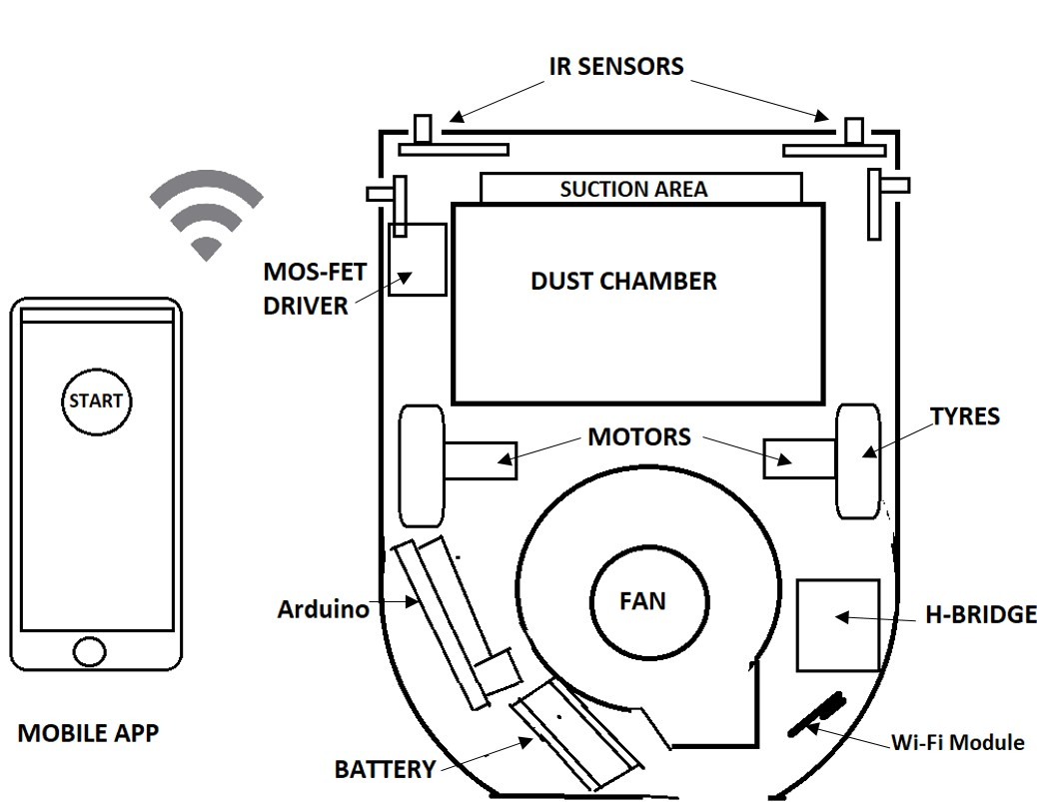

FIGURE 1: Physical Structure

* 1. **WORK BREAKDOWN STRUCTURE**

Following table shows our work breakdown

TABLE 5: Work break down structure

|  |  |  |
| --- | --- | --- |
| **Task** | **Start Date** | **Days to complete** |
| Research work | 20-Feb | 10 |
| Collect Material & Designing | 27-Feb | 40 |
| Assembling | 25-Mar | 17 |
| Coding and Calibrate | 10-Apr | 15 |
| IOT enable | 18-Apr | 8 |
| Testing | 27-Apr | 7 |

We have divided our work in six tasks, these task can overlap each other. We have started our work from the research we have visited lot of website, read research papers, watching videos, tutorials. From the research work we have decided our objectives and roles. Then we started collecting modules from different markets online as well as local market. It a long process because some of the specification varies so we have to find alternatives and work around. In parallel we also started Assembling the modules into our model. Once our basic circuit is completed we started coding and calibrating the device unit we get the satisfactory results. After that we made out project IoT enable for that we need to flash the Wi-Fi module and connect it to the Microcontroller and configure the app at the user end. Once it is done we have applied lot of testing on our project at different levels.

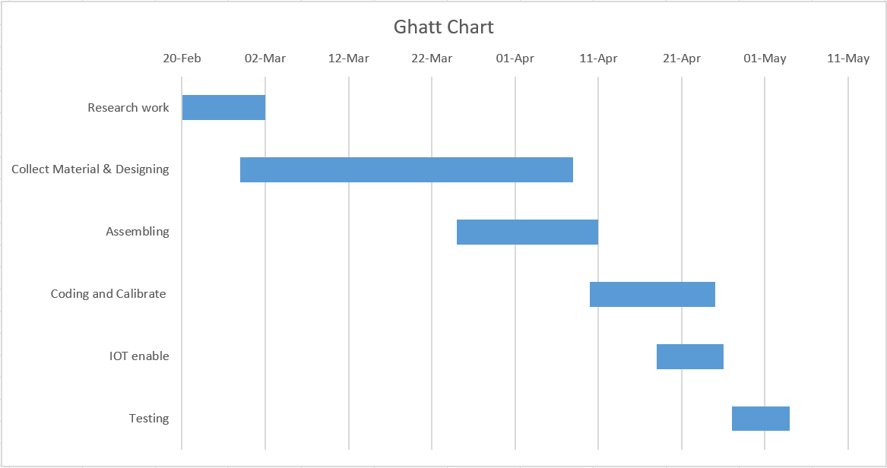

FIGURE 2: Ghatt chart

* 1. **TOOLS AND TECHNOLOGIES USED**

We have used following tools and technologies in our project

* Slack:We have created a group named “smart_cleaning” under the “me_project” to share the ideas. It helps to communicate with each other regarding the project problem, web-links, solutions, task responsibilities, reminders etc.
* Microcontroller: We have used Arduino UNO to control everything It is connected to the H-bridge, MOSFET Driver module sensors etc.
* Multimeter: Multimeter is very useful tool to measure the voltage at different level. It I used very heavily in our project in order to debug the circuit we need to measure the voltage on their end.
* Arduino IDE: For Arduino UNO programming and debugging we have used the Arduino IDE to write code and Serial Monitor to test it.
* GitHub:Github repository is used for the project backup and for sharing purpose. It acts as the version control system
* Blynk API: Blynk API is used to make our robot IoT enable.

**DESIGN SPECIFICATIONS**

This section contains the various diagrams used that describe the project and its most relevant screenshots.

**4.1 Architecture of the project**

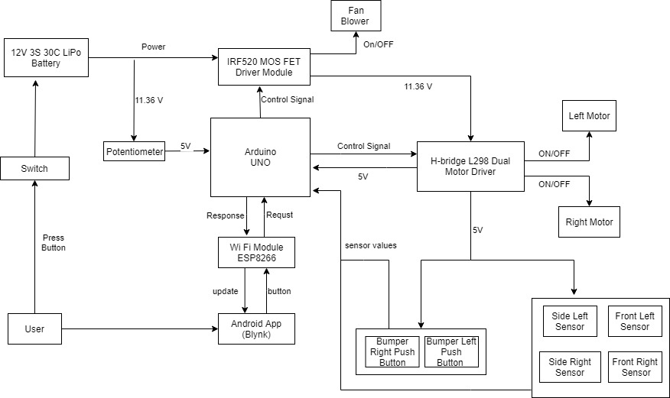

FIGURE 3: Block diagram

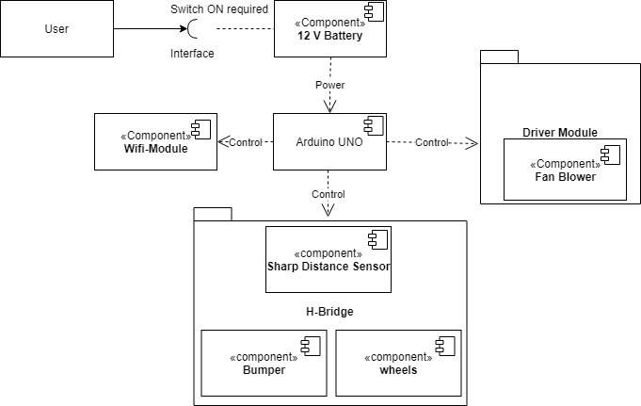

FIGURE 4: Component Diagram

**4.2 DESIGN LEVEL DIAGRAMS**

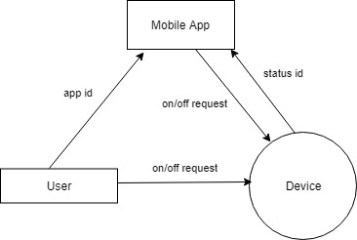

FIGURE 5: DFD level-0

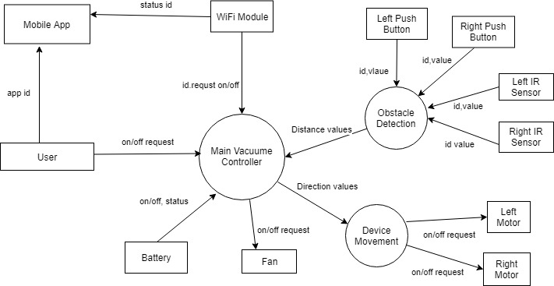

FIGURE 6: DFD Level-1

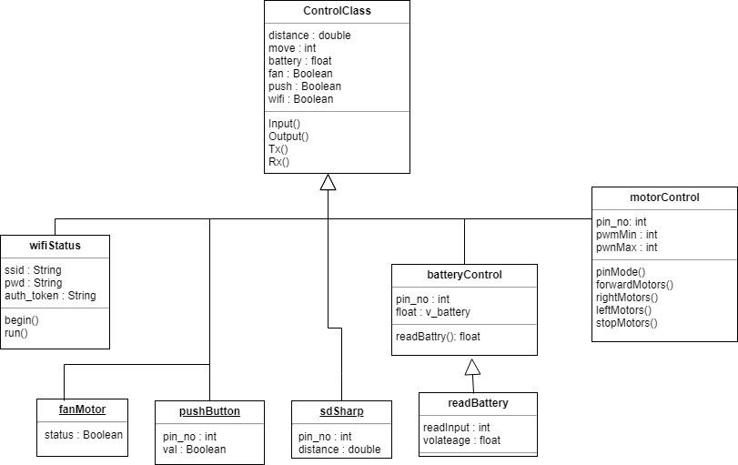

FIGURE 7: Class Diagram

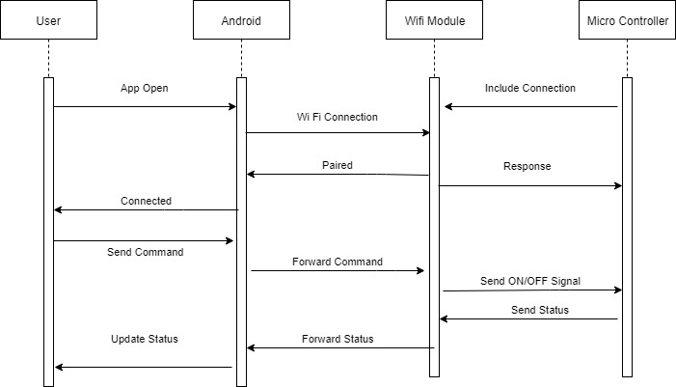

FIGURE 8: Sequence Diagram

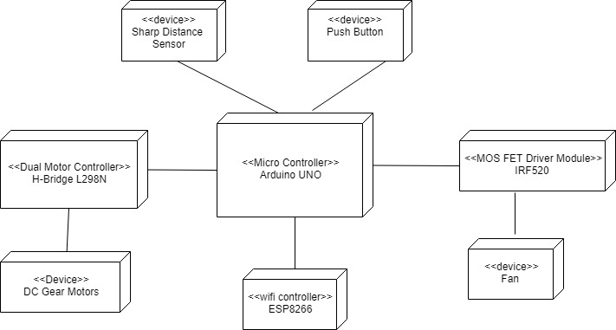

FIGURE 9: Deployment Diagram

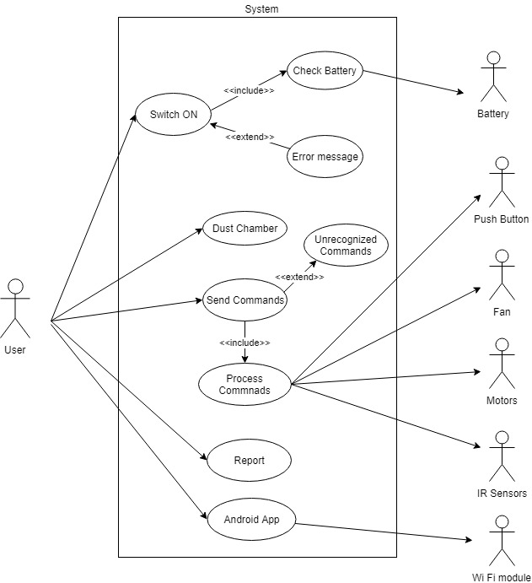

FIGURE 10: Use case diagram

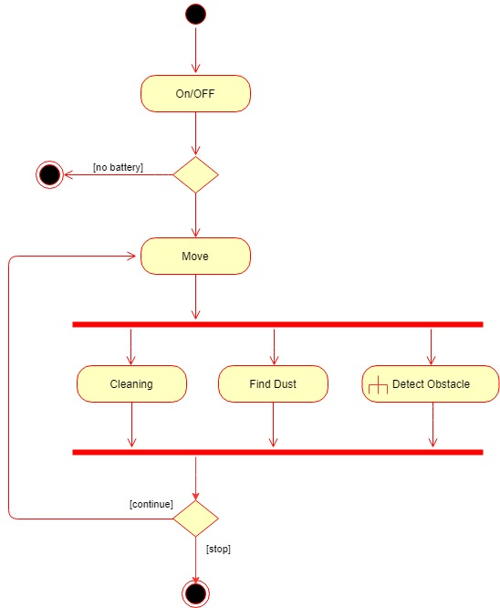

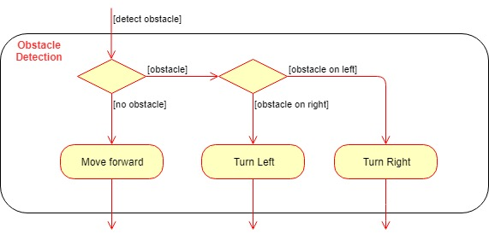

FIGURE 11: Activity Diagram

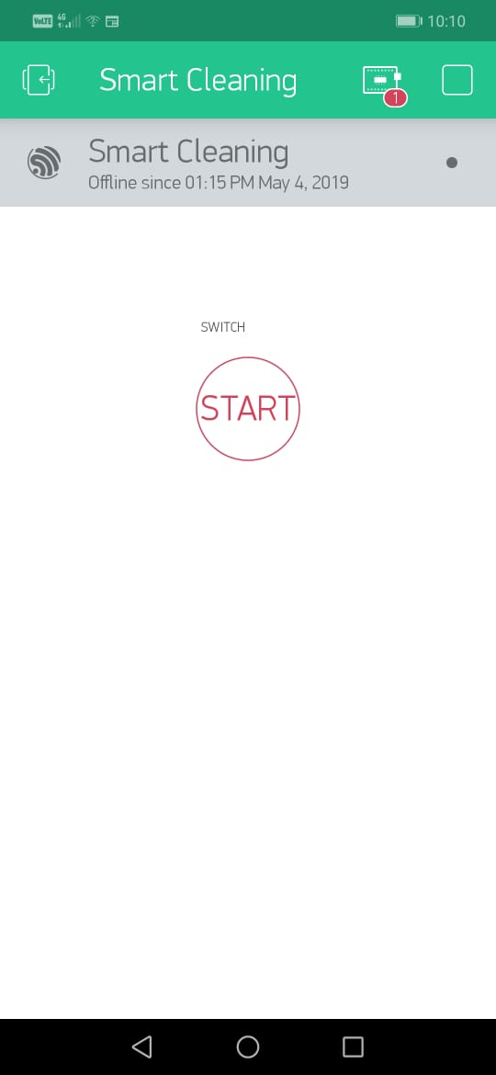

FIGURE 12: User Interface

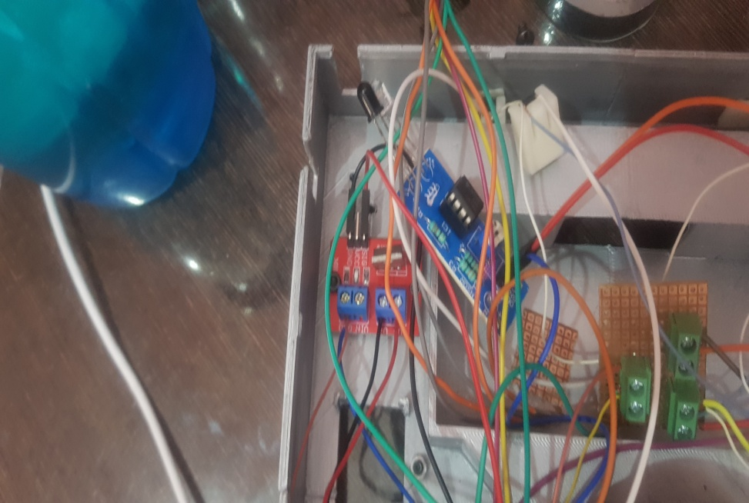

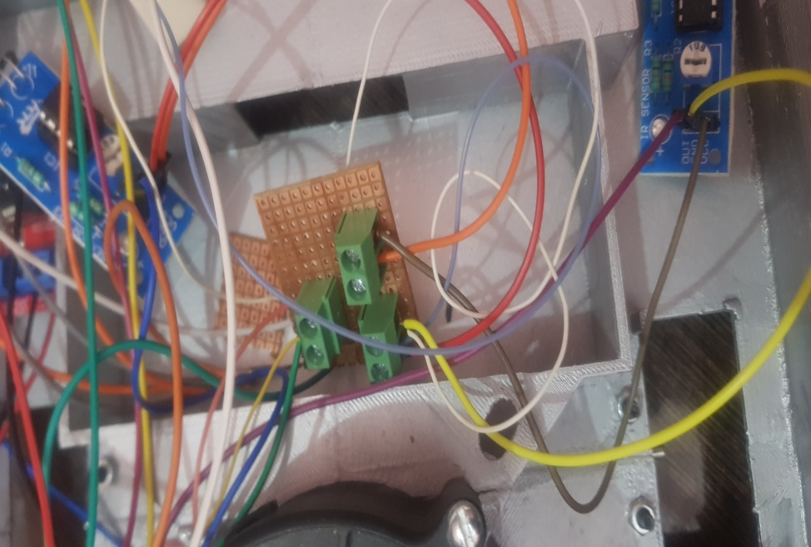

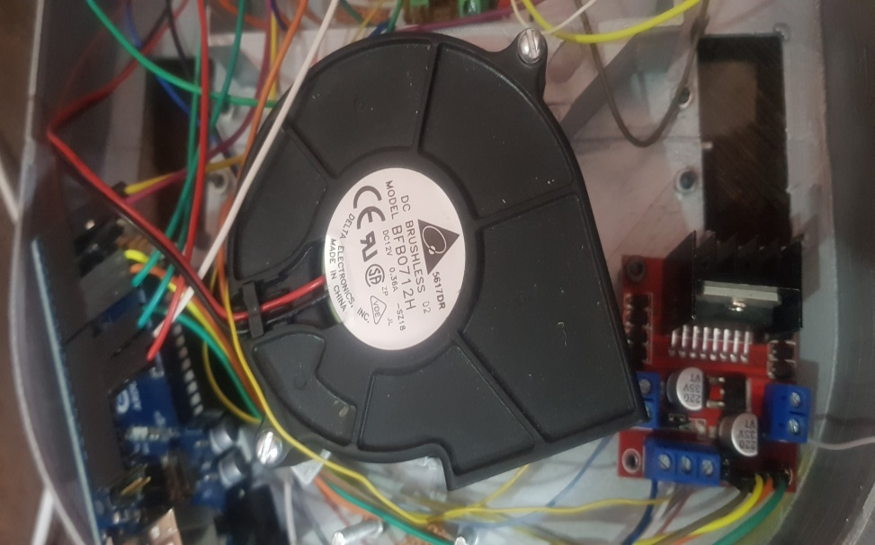

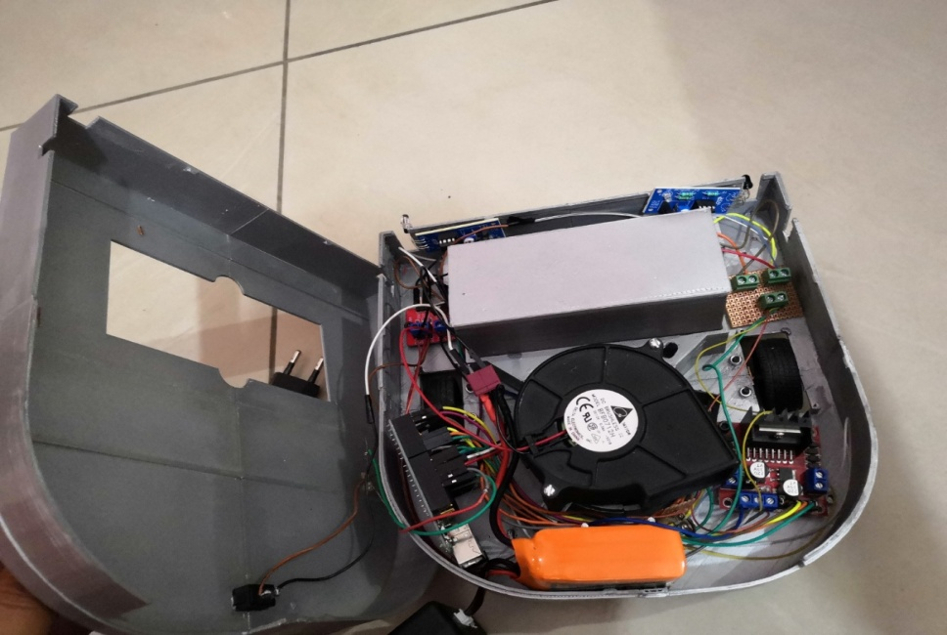

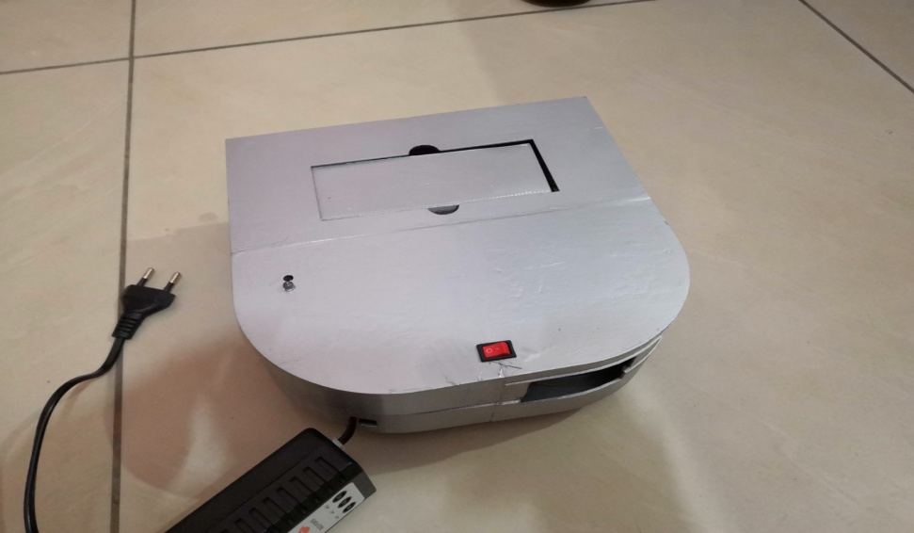

Figure 13: System Screenshots

**IMPLEMENTATION AND EXPERIMENTAL RESULTS**

* 1. **EXPERIMENTAL SETUP (OR SIMULATION)**

Setup of our project is very simple. Following steps are followed for setup:

1. Place the device on the plain surface.
2. Switch ON the button
3. The blue LED will start blinking after some time blue light becomes steady and robot stars moving and cleaning.
4. Open Blynk app, wait and check for device online.
5. Then we can Turn ON/OFF device from the app.
   1. **EXPERIMENTAL ANALYSIS**
      1. **DATA**

In our project we are not storing any data as soon as it is processed its gone. We have analyzed following data

* Sensors reading: Robot has four Infrared sensors two in front and two on side. They generate continuous input to Arduino. Arduino then process those input and move the motors accordingly in order to avoid obstacles.
* Battery voltage: We have to consistently measure the battery voltage so that if it drops from certain threshold the device will automatically stop otherwise it can harm the device.
* Motors Values: Motors control the movement of the device, Give the right value to the right motor is crucial task in order to avoid obstacles.
  + 1. **PERFORMANCE PARAMETERS**

We had evaluated main four tasks

* Cleaning time: The path followed by the robot is random. The average speed of the robot was 1 cm per second. The proposed system is capable of cleaning 3.85m × 2.67m room within 874.15 sec or 15 Min.
* Obstacle detection: Due to the limitations of infrared sensor, there are possibilities for minute errors, but it is negligible and comfortable for the operation of robot. There is no depth sensor in the device so cannot detect the edge in floor and height of the object
* Dust Collected: Dust chamber collect all the dust, It picks small objects of size 5mm and weight more than 50g cannot be sucked by the vacuum. The dust collected per square feet act as a performance measure assuming the equivalent dust on floor
* Mean Time Between Failure: Time between the failure of the device should be small, in our testing we have never observed any failure so far but stuck sometimes in corner.
  1. **TESTING PROCESS**
     1. **Test Plan**
        1. **Features to be tested**

Following features to be tested

* Cleaning: Cleaning ability depends on the suction capability of the Fan blower and the movement algorithm. We have used AVC 12V 2.34Amp fan blower with 26 CFM.
* Obstacle Detection: Objects are detected using the sensors. We have used four Infrared Sensors two in front and two on the side of the device.
* Battery life: Measured by on time per charge. We have used 11.1V 850mAh 3S LiPo Battery.
* IOT: Ability of the device to control form the Mobile device through the internet. We have used Blynk API to make out device IOT enabled.
  + - 1. **Test Strategy**

We have done testing our project at different levels unit testing, integration testing and system testing, decided the roles and responsibly of the individual, analyses the environmental requirements used various tools also setting the priorities.

In the unit testing we have tested each module separately, Different modules include H-Bridge input output voltage with millimeter, sensors value, MOS FET Driver Module, Fan Blower, Gear motors, Battery, Wi-Fi module, Arduino

In the Integration testing we have tested the H-Bridge functionality with the motors and Arduino with battery power supply, MOS FET Driver Module and fan blower with Arduino and power supply. ESP8266 Wi-Fi module with Arduino, Sensors with Arduino. Integrating the Blynk app with the ESP2866

In the System Testing all modules are tested together Arduino to control all modules by getting inputs from various sensors and output signal to motors accordingly turn ON/OFF fan according to the battery voltage received from the battery.

Deciding roles and responsibility for the testing according to the knowledge of the individual and design the test cases as per their roles.

Environment for testing is setup in such a way that each test case can be observed with the highest accuracy. The obstacles are place in a zig-zag manner to test the obstacle detection and avoid capability, Different area, size objects from small light weight to normal weight objects are placed on floor to test the suction power of the vacuum.

* + - 1. **Test Techniques**

Black box technique is used in the testing. There are the inputs that are given to the system through the environment using the sensors. The output of the system is observed in the environment itself for example by getting the particular value form the infrared sensor how the motors moves, does it avoid the obstacle or not.

Tools such as Millimeter is used to check the voltage at every point. Arduino IDE Serial Monitor is also used to check the values of the sensor and battery and motors and other debugging information.

* + 1. **Test Cases**

TABLE 6 : Test Case 1

|  |  |
| --- | --- |
| **Test Case** | |
| **Test Case ID:** 01 | **Test Designed by:** Kamal Kant |
| **Test Priority (Low/Medium/High):** High | **Test Designed date:** 25-04-2019 |
| **Module Name:** Obstacledetection | **Test Executed by:** Harmandeep |
| **Test Title:** Sharp Distance Measure | **Test Execution date:** 27-04-2019 |
| **Description:** Through the sharp distance sensor avoid the specific obstacle |  |

|  |
| --- |
| **Pre-conditions:** 1. Circuit should be connected. 2. Sharp Distance sensor should be functional 3. |

|  |  |  |  |  |
| --- | --- | --- | --- | --- |
| **Step** | **Test Steps** | **Expected System Response** | **Status**  **(Pass/Fail)** | **Notes** |
| 1 | Get the value from the IR sensor | Value Measured Successfully | Pass |  |
| 2 | Process the value in the main controller | Process the value  (x^-0.857)1167.9 | Pass | x is the value returned from the sensor |
| 3 | Move the device to avoid obstacle | If distance from obstacle < 4.3 cm move to another direction | Pass |  |

TABLE 7: Test Case 2

|  |  |
| --- | --- |
| **Test Case** | |
| **Test Case ID:** 02 | **Test Designed by:** Gurkirat Singh |
| **Test Priority (Low/Medium/High):** Medium | **Test Designed date:** 26-04-2019 |
| **Module Name:** Gear Motor | **Test Executed by:** Kamal Kant |
| **Test Title:** Movement of Device | **Test Execution date:** 28-04-2019 |
| **Description:** Test the motors individually to forward , backward, left, right turn. |  |

|  |
| --- |
| **Pre-conditions:** 1. Circuit should be connected. 2. H-Bridge functioning properly |

|  |  |  |  |  |
| --- | --- | --- | --- | --- |
| **Step** | **Test Steps** | **Expected System Response** | **Status**  **(Pass/Fail)** | **Notes** |
| 1 | Send signal to motor to move forward | Device move forward | Pass |  |
| 2 | Send right motor high and left low | Turn right | Pass |  |
| 3 | Send left motor high and right low | Turn left | Pass |  |
| 4 | Switch the signals to move antilock wise or backward | Backward | Pass |  |

TABLE 8: Test Case 3

|  |  |
| --- | --- |
| **Test Case** | |
| **Test Case ID:** 03 | **Test Designed by:** Harmandeep |
| **Test Priority (Low/Medium/High):** High | **Test Designed date:** 20-04-2019 |
| **Module Name:** Battery Power | **Test Executed by:** Jhonsy Bansal |
| **Test Title:** Battery level | **Test Execution date:** 28-04-2019 |
| **Description:** Test the battery to power device and if battery discharges then switch off the devices. |  |

|  |
| --- |
| **Pre-conditions:** 1. Circuit should be connected. 2. IRF520 MOS FET Driver Module |

|  |  |  |  |  |
| --- | --- | --- | --- | --- |
| **Step** | **Test Steps** | **Expected System Response** | **Status**  **(Pass/Fail)** | **Notes** |
| 1 | Send 5v to Arduino through potentiometer | Arduino receive 5V signal | Pass | Raw 11.1V cannot be supplied to Arduino, it will damage it. |
| 2 | Calculate voltage | Calculate volatege out of 11.1V | Pass | (((readInput*4.9)/1000)*voltageBatCharged ) / 5; |
| 3 | If (Voltage < 11) stop devices | Fan and motors should be off. | Pass |  |

TABLE 9: Test Case 4

|  |  |
| --- | --- |
| **Test Case** | |
| **Test Case ID:** 04 | **Test Designed by:** Jhonsy Bansal |
| **Test Priority (Low/Medium/High):** Low | **Test Designed date:** 28-04-2019 |
| **Module Name:** WiFi Connection | **Test Executed by:** Gurkirat |
| **Test Title:** Remotely enable disable device | **Test Execution date:** 30-04-2019 |
| **Description:** Connect wifi and start and stop the device using Android App |  |

|  |
| --- |
| **Pre-conditions:** 1. Wifi Module is connected to Arduino 2. Wifi Network with active internet is available |

|  |  |  |  |  |
| --- | --- | --- | --- | --- |
| **Step** | **Test Steps** | **Expected System Response** | **Status**  **(Pass/Fail)** | **Notes** |
| 1 | Connect to the WiFi Hotspot | Connected | Sometimes Fails | Flash the wifi module (ESP8266) with ssid and pass and Blynk libraries. |
| 2 | Connect to Blynk Server | Connection established | Pass | (((readInput*4.9)/1000)*voltageBatCharged ) / 5; |
| 3 | Send ON/OFF signal from Android to ESP8266 | App send signal successfully | Pass |  |
| 4 | Microcontroller receive request from ESP8266 and Start or Stop device | Device Turn On or OFF | Sometimes expecting delays |  |

TABLE 10: Test Case 5

|  |  |
| --- | --- |
| **Test Case** | |
| **Test Case ID:** 05 | **Test Designed by:** Harmadeep |
| **Test Priority (Low/Medium/High):** High | **Test Designed date:** 30-04-2019 |
| **Module Name:** Avoid detection | **Test Executed by:** Kamal Kant |
| **Test Title:** Sharp Distance Measure | **Test Execution date:** 30-04-2019 |
| **Description:** Through the sharp distance sensor avoid the obstacle |  |

|  |
| --- |
| **Pre-conditions:** 1. Circuit should be connected. 2. Sharp Distance sensor should be functional |

|  |  |  |  |  |
| --- | --- | --- | --- | --- |
| **Step** | **Test Steps** | **Expected System Response** | **Status**  **(Pass/Fail)** | **Notes** |
| 1 | Get the value from the IR sensor | Value Measured Successfully | Pass |  |
| 2 | Process the value in the main controller | Process the value  (x^-0.857)1167.9 | Pass | x is the value returned from the sensor |
| 3 | Obstacle height is < 2cm | If distance from obstacle < 4.3 cm move to another direction | Fail |  |

TABLE 11: Test Case 6

|  |  |
| --- | --- |
| **Test Case** | |
| **Test Case ID:** 05 | **Test Designed by:** Jhonsy Bansal |
| **Test Priority (Low/Medium/High):** High | **Test Designed date:** 30-04-2019 |
| **Module Name:** Avoid falling | **Test Executed by:** Kamal Kant |
| **Test Title:** Sharp edge | **Test Execution date:** 30-04-2019 |
| **Description:** Through the sharp distance sensor avoid the obstacle |  |

|  |
| --- |
| **Pre-conditions:** 1. Circuit should be connected. 2. Sharp Distance sensor should be functional |

|  |  |  |  |  |
| --- | --- | --- | --- | --- |
| **Step** | **Test Steps** | **Expected System Response** | **Status**  **(Pass/Fail)** | **Notes** |
| 1 | Get the value from the IR sensor | Value Measured Successfully | Pass |  |
| 2 | Process the value in the main controller | Process the value  (x^-0.857)1167.9 | Pass | x is the value returned from the sensor |
| 3 | Sharp edge depth | If distance from surface > 1.5 cm move backward | Fail |  |

* + 1. **Test Results**

Most of the test results are passed by the robot. Robot successfully avoid the obstacle in its proximity. Due to the lake of sensors some of the obstacle like stairs or height are not measured. The device can stuck in some places because the quality of the sensors are not good some of the objects are not captured by the robot. Gear motors passes in all the cases. Power supply test case also passes all the modules gets right amount of power. Due to the lake of depth sensor robot does not detect the sharp edge depth. Wi-Fi module get stuck sometimes because it is highly dependent on the availability of the Access Point when turned on the device.

* 1. **RESULTS AND DISCUSSIONS**

Tests were carried out on the prototype device to see its effectiveness as to what degree it meets our expected performance. At first both device and obstacle are made face to each other to see if it would avoid it or not. Then multiple obstacles are placed to see how the device will respond. In some cases, the device stuck. The physical realization of the system is very important. After carrying all the paper design and analyses, changing the coding the system was implemented and tested again to ensure its working ability, and finally the construction meet the desired specification.

* 1. **INFERENCES DRAWN**

We have to add more sensors in order to increase the accuracy of the obstacle avoidance. We need to add more test cases to check every possible of the obstacle. There should be some system through which user has to notify that the device is stuck.

* 1. **VALIDATION OF OBJECTIVES**

Our objectives were

* Connecting and Assembling hardware.

This objective is successfully accomplished. The circuit and pin configuration of the modules are valid. Assembling the modules in the models efficiently was an interesting task

* Calibrating Hardware.

Setting the hardware using the Arduino is a iterative process. Write the code and upload it to Arduino and test it. We have done this number of times and achieve the satisfactory result.

* Enable IoT

To make our project IoT enable first flashing the ESP8266 Wi-Fi with different pin configuration. On the other side configure the Blynk app and connect in to W-Fi module. We have successfully turned ON and OFF robot from the app using the internet.

**IMPLEMENTATION AND EXPERIMENTAL RESULTS**

* 1. **CONCLUSIONS**

The project is definitely a very important product in robotics and floor cleaning area. The robot developed so far are very complex and costly. Our project shows a better and simple approach to provide an overview of design of a simple robotic cleaners design using tools and instruments easily available.This robot is specially made on the basis of modern technology. This robot has very compact design so also very handy in portability. It has all the basic features which are required for a floor vacuum cleaner. It can also be used for the industries where cleaning with the help of human is toxic, vacuum cleaner can easily be used. Also future researches work and updates can be ensured to keep the robot developed by more efficient path routing method and research on using other sensors for detecting waste and obstacles can be able to bring more improvising too.

* 1. **ENVIRONMENTAL, ECONOMIC AND SOCIETAL BENEFITS**

The environmental benefit of our project are it does not spread the dust for instance when we clean the floor using broom we keep forwarding and then collect the dust in this procedure some of the dust particles remains in the air on the other side vacuum cleaner robot sucks it and prevent the particles for being spread. Second, Previous designs of vacuum cleaner consumes lot of power our design is an energy efficient and can even be improved by various techniques.

Economically our project cost very less as compared to other products available in market, it will cost even lesser then this because we made this first time so used some redundant and costly material in future we can choose batter and cheaper alternatives for the same. It also need very less workforce.

It will keep the floor clean and prevent the allergies due to the dust. You can devote your time somewhere else which is more productive then cleaning your floor. Anyone can use it according to their convenience.

* 1. **FUTURE WORK**

There is lot of future scope in this work. From the current and future research we can implement the following ideas in our project:

We can include more sensors like depth sensors, ultrasonic sensors etc. we can apply Mapping Algorithm for better cleaning in the room this will also help in saving energy.

We can use various AI techniques like Machine Learning to improve how our will move and clean for example there are certain areas in the room which gets dirty more often than other the robot can clean them more frequently than other areas.

Interactive reporting can be shown to the users in the form of graphs or charts about the cleaning history of the device.

More smart features like automatic charging, schedule cleaning, automatic error diagnose and reporting can be implemented

**REFERENCES**

|  |  |
| --- | --- |
| S. No.  [1] | Monika, A. S, Manjusha, B. K Aruna. Prasad, C. SVS, Naresh, D. B. “Design and Implementation of Smart Floor  Cleaning Robot using Android App”  *International Journal of Innovative Technology and Exploring Engineering (IJITEE)*, ISSN: 2278-3075, Volume-8 Issue-4S2 March, 2019 |
| S. No.  [2] | John, A. Ajay P, Varghese, B. Alex. P B, C. Amrutha, Thomas, D. Ann Susan, Peter, E. Megha . “Implementation of an Automated Smart  Robotic Floor Cleaner” *International Journal of Advanced Research in Electrical,*  *Electronics and Instrumentation Engineering (IJAREEIE)*, Vol. 6, Issue 4, April 2017 |
| S. No.  [3] | Wan, A. Jiafu, Tang, Shenglong B. Tang, Shu, C. Zhaogang, Shiyong, D. Wang,  Muhammad, E. Imran, Athanasion, F. Vasilakos. “Software-Defined Industrial Internet of Things  in the Context of Industry 4.0”,  *IEEE Sensors Journal*, VOL. 16, NO. 20, OCTOBER 15, 2016 |

|  |  |
| --- | --- |
| S. No.  [4] | Khalid, A. Uman, Baloch B. Muhammad Faizan. “Smart Floor Cleaning Robot (CLEAR)”  In *IEEE Standard University*. 2015 |

|  |  |
| --- | --- |
| S. No.  [5] | CesNieto. “DIY Vacuum Robot”, Internet: [www.instructables.com/id/Build-Your-Own-Vacuum-Robot](http://www.instructables.com/id/Build-Your-Own-Vacuum-Robot) , May 19, 2017 [May. 2, 2019]. |